

Project Proposal

For R&W application

Tutor: Doan Trung Tung

Student: Dinh Thi Quyen

ID: 001126068

Contents

1. Introduction 3

2. Aim 4

3. Objectives 4

3.1 To gather requirements for my system 4

3.2 To plan for my project 4

3.3 To choose technology development 4

3.4 To design system 5

3.5 To implement my app 5

3.6 To test my app 5

3.7 To make final report 5

4. Legal, Social, Ethical and Professional 6

5. Planning 7

Bibliography 8

# Introduction

Ever since I was young, I had a special interest in reading books and romantic love stories. However, I had difficulty finding and choosing a book or a story that suited my interests. I'm sure there will be many people who have difficulty folding like me.

With the development of technology, I gradually became aware of websites for reading stories, so my reading also became easier. After a long time using the web to read stories and learn to code, I cherished an intention to create an application of my own where people with the same passion as me could share feelings and our thoughts on a certain work. At the same time with my admiration for the authors, I hope that I can directly interact, talk, comment with the author on their stories through the internet. Through the application, I can also follow new works or new stories of the author or my favorite stories.

Besides, the passion for reading has helped me to cultivate a love of writing, it will be interesting if my works can be more popular and well received. I think there must be many who want it as much as I do. So, the application not only allows users to read and interact with other people's works but also publish their works.

This desire motivated me to create an application that I called R&W, which stands for Read and Write. It will be my final project.

I think that I will create an application in Android so IDE I use for this project is Android Studio and programming language I use for the project is Kotlin. Kotlin is the most likely language for develop Android applications. Kotlin syntax is concise, simple, easy to learn and understand. Because of less code and better readability so Kotlin has fewer errors. Kotlin mainly targets the JVM. Although Kotlin’s syntax is not compatible with Java but for Android apps, it can interoperate with Java code. Kotlin’s community is becoming more and more widely and development. (Samojło, 2019)

Android studio is the most popular and famous IDE for making Android applications that developed by Google and JetBrains. Android studio support for 3 programming languages are Java, Kotlin and C++. Android Studio GUI allows user can interactive with many types of mobile devices. Android Studio helps developers faster in development, testing and deployment. (Solutions, 2016)

# Aim

The aim of my project is that creates an environment of freedom of exchange and sharing for those who are passionate about reading stories and writing creek.

# Objectives

## To gather requirements for my system

**Activities:**

* List the desired functions to be included in the application.
* Compare with similar products.
* Describe functions for system and sort them by priority.

**Deliverables:**

* A document which describes in detail the function of the system.

## To plan for my project

**Activities:**

* Making the work breakdown structure(WBS).
* Making Gantt chart.

**Deliverables:**

* A document including WBS and Gantt chart.

## To choose technology development

**Activities:**

* Choosing development IOS app or Android app.
* Choosing backend programing
* Choosing font end programing.
* Choosing database language.
* Choosing IDE.

**Deliverables:**

* A document about decision IOS app or Android app, backend programing, font-end programing, database language, IDE.

## To design system

**Activities:**

* Making UML diagram.
* Making user interface design.
* Making database design.
* Writing a report.

**Deliverables:**

* UML diagram.
* User interface.
* Entity Relationship Diagram.
* A system description design report.

## To implement my app

**Activities:**

* Implement database.
* Coding (font-end, backend).

**Deliverables:**

* An application.

## To test my app

**Activities:**

* Testing system.
* Writing a report (test log).

**Deliverables:**

* A report of test log.

## To make final report

**Activities:**

* Get user reviews through the survey.
* Evaluation system (weakness, strength) and describe system (functional).
* Evaluation development process (difficult while development).
* Evaluation about applied technology.
* Lessons learned after the project.
* Conclusion.
* Writing a final report.

**Deliverables:**

* A final report.

# Legal, Social, Ethical and Professional

**Legal**

* My products have online transactions with donate function so must comply with the confidentiality of customer information during the transaction.
* User information must be kept confidential, avoiding the act of secreting user information.
* Users are free to compose and upload their stories so copyright and intellectual property issues are respected.

**Social**

* Users can link to social accounts to share stories.
* Readers of the story are free to express and evaluate stories according to their personal senses.
* Readers can follow and chat with users like a social network.

**Ethical**

* Review and process user reports about the story seriously and fairly.
* Forbid to post pornographic, violent, etc.

**Professional**

* Improve product quality through programming skills.
* Regularly maintain and upgrade applications to ensure product quality.

# Planning

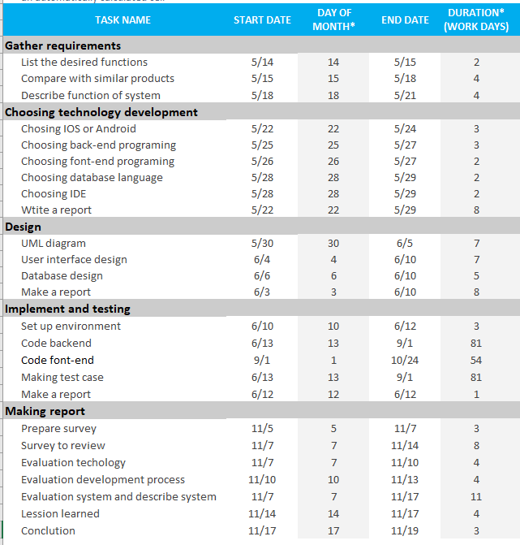

# Bibliography

Samojło, G. (2019, 9 2). *Pros and Cons of the Kotlin Programming Language for Developing Android Apps*. Retrieved from netguru.com: https://www.netguru.com/blog/kotlin-pros-and-cons

Solutions, R. I. (2016, 5 19). *Top 5 Benefits from Android Studio 2.0 for an Android App Development Company*. Retrieved from rootinfosol.com: https://www.rootinfosol.com/top-5-benefits-from-android-studio-2-0-for-an-android-app-development-company